

SIMPLE E-COMMERCE PLATFORM

A PROJECT REPORT
Submitted by

AJMAL AHAMED J(2303811714821003)

in partial fulfillment of requirements for the award of the course
CGB1221-DATABASE MANAGEMENT SYSTEMS
in

ARTIFICIAL INTELLIGENCE AND MACHINE LEARNING

K. RAMAKRISHNAN COLLEGE OF TECHNOLOGY
(An Autonomous Institution, affiliated to Anna University Chennai and Approved by AICTE, New Delhi)

SAMAYAPURAM – 621 112

JUNE- 2025

K. RAMAKRISHNAN COLLEGE OF TECHNOLOGY
(AUTONOMOUS)
SAMAYAPURAM – 621 112

BONAFIDE CERTIFICATE

Certified that this project report on “ Simple E-commerce Platform” is the bonafide work of AJMAL AHAMED J(2303811714821003) who carried out the project work during the academic year 2024 - 2025 under my supervision.
 | 
SIGNATURE  Dr.T.AVUDAIAPPAN, M.E.,Ph.D.,  HEAD OF THE DEPARTMENT  ASSOCIATE PROFESSOR  Department of Artificial Intelligence  K.Ramakrishnan College of Technology (Autonomous)  Samayapuram–621112. | SIGNATURE  Mr.R.ROSHAN JOSHUA, M.E.,  SUPERVISOR  ASSISTANT PROFESSOR  Department of Artificial Intelligence  K.Ramakrishnan College of Technology (Autonomous)  Samayapuram–621112.

Submitted for the viva-voce examination held on …04.06.2025……………….

INTERNAL EXAMINER | EXTERNAL EXAMINER
DECLARATION

I declare that the project report on “Simple E-commerce Platform” is the result of original work done by us and best of our knowledge, similar work has not been submitted to “ANNA UNIVERSITY CHENNAI” for the requirement of Degree of BACHELOR OF ENGINEERING. This project report is submitted on the partial fulfilment of the requirement of the completion of the course CGB1221 – DATABASE MANAGEMENT SYSTEMS.

Signature



Name of the Student

Place: Samayapuram

Date:04/06/20025

ACKNOWLEDGEMENT

It is with great pride that I express our gratitude and in-debt to our institution “K.Ramakrishnan College of Technology (Autonomous)”, for providing us with the opportunity to do this project.

I glad to credit honourable chairman Dr. K. RAMAKRISHNAN, B.E., for having provided for the facilities during the course of our study in college.

I would like to express our sincere thanks to our beloved Executive Director Dr. S. KUPPUSAMY, MBA, Ph.D., for forwarding to our project and offering adequate duration in completing our project.

I would like to thank Dr. N. VASUDEVAN, M.Tech., Ph.D., Principal, who gave opportunity to frame the project the full satisfaction.

I whole heartily thanks to Dr. T. AVUDAIAPPAN, M.E.,Ph.D., Head of the department, ARTIFICIAL INTELLIGENCE for providing his encourage pursuing this project.

I express our deep expression and sincere gratitude to our project supervisor Mr.R.ROSHAN JOSHUA, M.E., Department of ARTIFICIAL INTELLIGENCE, for his incalculable suggestions, creativity, assistance and patience which motivated us to carry out this project.

I render our sincere thanks to Course Coordinator and other staff members for providing valuable information during the course.

I wish to express our special thanks to the officials and Lab Technicians of our departments who rendered their help during the period of the work progress.

INSTITUTE
Vision:
- To serve the society by offering top-notch technical education on par with global standards.
Mission:
- Be a center of excellence for technical education in emerging technologies by exceeding the needs of industry and society.
- Be an institute with world class research facilities.
- Be an institute nurturing talent and enhancing competency of students to transform them as all – round personalities respecting moral and ethical values.

DEPARTMENT
Vision:

- To become a renowned hub for AIML technologies to producing highly talented globally recognizable technocrats to meet industrial needs and societal expectation.

Mission

- To impart advanced education in AI and Machine Learning, built upon a foundation in Computer Science and Engineering.
- To foster Experiential learning equips students with engineering skills to tackle real-world problems.
- To promote collaborative innovation in AI, machine learning, and related research and development with industries.
- To provide an enjoyable environment for pursuing excellence while upholding strong personal and professional values and ethics.

PROGRAM EDUCATIONAL OBJECTIVES (PEO)

- PEO1: Excel in technical abilities to build intelligent systems in the fields of AI & ML in order to find new opportunities.
- PEO2: Embrace new technology to solve real-world problems, whether alone or as a team, while prioritizing ethics and societal benefits.
- PEO3: Accept lifelong learning to expand future opportunities in research and product development.

PROGRAM SPECIFIC OUTCOMES (PSO)
- PSO1: Expertise in tailoring ML algorithms and models to excel in designated applications and fields.
- PSO2: Ability to conduct research, contributing to machine learning advancements and innovations that tackle emerging societal challenges.

PROGRAM OUTCOMES (POs)
Engineering students will be able to:
- Engineering knowledge: Apply the knowledge of mathematics, science, engineering fundamentals, and an engineering specialization to the solution of complex engineering problems.
- Problem analysis: Identify, formulate, review research literature, and analyze complex engineering problems reaching substantiated conclusions using first principles of mathematics, natural sciences, and engineering sciences
- Design/development of solutions: Design solutions for complex engineering problems and design system components or processes that meet the specified needs with appropriate consideration for the public health and safety, and the cultural, societal, and environmental considerations
- Conduct investigations of complex problems: Use research-based knowledge and research methods including design of experiments, analysis and interpretation of data, and synthesis of the information to provide valid conclusions
- Modern tool usage: Create, select, and apply appropriate techniques, resources, and modern engineering and IT tools including prediction and modeling to complex engineering activities with an understanding of the limitations
- The engineer and society: Apply reasoning informed by the contextual knowledge to assess societal, health, safety, legal and cultural issues and the consequent responsibilities relevant to the professional engineering practice
- Environment and sustainability: Understand the impact of the professional engineering solutions in societal and environmental contexts, and demonstrate the knowledge of, and need for sustainable development
- Ethics: Apply ethical principles and commit to professional ethics and responsibilities and norms of the engineering practice.
- Individual and team work: Function effectively as an individual, and as a member or leader in diverse teams, and in multidisciplinary settings.
- Communication: Communicate effectively on complex engineering activities with the engineering community and with society at large, such as, being able to comprehend and write effective reports and design documentation, make effective presentations, and give and receive clear instructions.
- Project management and finance: Demonstrate knowledge and understanding of the engineering and management principles and apply these to one’s own work, as a member and leader in a team, to manage projects and in multidisciplinary environments.
- Life-long learning: Recognize the need for, and have the preparation and ability to engage in independent and life-long learning in the broadest context of technological change.

ABSTRACT

In the digital era, e-commerce platforms play a vital role in transforming traditional shopping methods into seamless online experiences. This project focuses on designing and implementing a simple yet functional e-commerce database system to manage real-time operations such as product listing, customer registration, order processing, and transaction management. The system is built using a relational database management system (RDBMS), emphasizing database normalization, integrity constraints, and SQL-based CRUD operations.
The platform consists of multiple interrelated entities such as Customers, Products, Orders, Payments, and Categories, modeled using Entity-Relationship Diagrams (ERDs). The database supports essential functionalities including searching products, placing orders, tracking deliveries, and managing user accounts. It ensures data consistency, concurrency, and secure access control.
This project demonstrates how a well-structured database can support the core functionalities of an e-commerce system, enabling scalability and efficiency. It also incorporates concepts of indexing, stored procedures, and transaction control to enhance performance and reliability.

ABSTRACT WITH POs AND PSOs MAPPING

CO 5 : BUILD DATABASES FOR SOLVING REAL-TIME PROBLEMS.
ABSTRACT | POs MAPPED | PSOs MAPPED
In the digital era, e-commerce platforms play a vital role in transforming traditional shopping methods into seamless online experiences. This project focuses on designing and implementing a simple yet functional e-commerce database system to manage real-time operations such as product listing, customer registration, order processing, and transaction management. The system is built using a relational database management system (RDBMS), emphasizing database normalization, integrity constraints, and SQL-based CRUD operations.  The platform consists of multiple interrelated entities such as Customers, Products, Orders, Payments, and Categories, modeled using Entity-Relationship Diagrams (ERDs). The database supports essential functionalities including searching products, placing orders, tracking deliveries, and managing user accounts. It ensures data consistency, concurrency, and secure access control.  This project demonstrates how a well-structured database can support the core functionalities of an e-commerce system, enabling scalability and efficiency. It also incorporates concepts of indexing, stored procedures, and transaction control to enhance performance and reliability. | PO1 -3  PO2 -3  PO3 -3  PO4 -3  PO5 -3  PO6 -3  PO7 -3  PO8 -3  PO9 -3  PO10 -3  PO11-3  PO12 -3 | PSO1 -3  PSO2 -3  PSO3 -3
Note: 1- Low, 2-Medium, 3- High

TABLE OF CONTENTS
CHAPTER NO. | TITLE | PAGE NO.
 | ABSTRACT
1 | INTRODUCTION
 | 1.1 Objective
 | 1.2 Overview
 | 1.3 SQL and Database concepts
2 | PROJECT METHODOLOGY
 | 2.1 Proposed Work
 | 2.2 Block Diagram
3 | MODULE DESCRIPTION
 | 3.1 3.1 User Management Module
 | 3.2 Product Management Module
 | 3.3 Cart and Order Module
 | 3.4 Payment Module
 | 3.5 Admin Module
4 | CONCLUSION & FUTURE SCOPE
5 | APPENDIX A SOURCE CODE
 | APPENDIX B SCREENSHOTS
 | REFERENCES

CHAPTER 1: INTRODUCTION

  - Objective
To design and develop a simple e-commerce database system that facilitates real-time operations such as user registration, product browsing, ordering, and payment, ensuring data consistency, security, and performance.
- Design a relational database for managing products, users, orders, and transactions.
- Implement secure user registration and authentication.
- Enable product search, selection, and cart management.
- Track order history and status updates.
- Facilitate a basic admin interface for inventory and order management.
  - Overview
An e-commerce platform is a digital system that enables buying and selling of products online. This project focuses on the backend development of a Simple E-Commerce Platform using a relational database. The system manages various real-time operations such as user registration, product catalog management, cart handling, order processing, and payment tracking.
The goal is to build a structured and normalized database that supports consistent, efficient, and secure data handling. Users can browse products, add them to a cart, place orders, and simulate payments. An admin can manage product listings, monitor inventory, and view customer orders. This application serves as a practical demonstration of how DBMS principles—like normalization, referential integrity, and SQL operations—can be applied to a real-world e-commerce scenario.
The system is built using:
- SQLite for backend database management
- SQL for queries and data manipulation
- Python + Gradio for interface and application logic (optional frontend)
This project highlights the importance of effective database design in ensuring the performance and scalability of modern business applications.
  - SQL and Database Concepts

The project utilizes essential DBMS principles:
1.Normalization:
The database is designed in a normalized form to eliminate data redundancy and maintain data integrity across users, products, orders, and payments.
2.Schema Structure:
- Users table includes: user_id, username, email, password
- Products table includes: product_id, name, description, price, category_id, stock
- Orders table includes: order_id, user_id, order_date, status, total_amount
- Order_Items table includes: order_id, product_id, quantity, price
- Payments table includes: payment_id, order_id, payment_date, amount, payment_method, status.
3.Relationships:
Foreign key constraints are used to link related tables, such as associating orders with users (Orders.user_id → Users.user_id), order items with orders and products, and payments with orders, ensuring referential integrity.
4.SQL Operations:
- SELECT to retrieve products, user orders, and payment history
- INSERT to add new users, products, orders, and payments
- UPDATE to modify stock quantities and order statuses
- DELETE to remove orders or products when necessary
- JOIN operations to generate comprehensive admin views combining data from multiple tables (e.g., order details with user and payment information)
- Security:
Basic protection against duplicate usernames and emails is enforced using the UNIQUE constraint, and passwords are securely stored (e.g., hashed). Foreign key constraints also help maintain data consistency.

CHAPTER 2: PROJECT METHODOLOGY

2.1 Proposed Work
The proposed work involves designing and implementing a robust database system for a simple e-commerce platform that efficiently manages users, products, orders, and payments. The main objectives include:
1.Database Design and Normalization:
- Develop a normalized database schema that minimizes data redundancy and maintains data integrity across all entities such as users, products, orders, and payments.
- Define tables with appropriate primary keys, foreign keys, and constraints to enforce relationships and consistency.
2.Implementation of Core Functionalities:
- Create tables for users, products, categories, orders, order items, and payments with SQL commands.
- Implement CRUD (Create, Read, Update, Delete) operations using SQL queries to manage platform data effectively.
3.User Management:
- Enable user registration and authentication with validation to prevent duplicate usernames and emails.
- Secure password storage using hashing techniques (if applicable).
4.Product Management:
- Allow adding, updating, and deleting products, including categorization and stock management.

5.Order Processing:
- Enable users to place orders with multiple products and quantities.
- Track order statuses and calculate total amounts dynamically.
6.Payment Handling:
- Record payment transactions linked to orders.
- Support multiple payment methods and track payment statuses.
7.Reporting and Admin Views:
- Use JOIN operations to generate comprehensive reports for admins showing orders, payment statuses, and user activities.
8.Data Security and Integrity:
- Implement constraints such as UNIQUE, NOT NULL, and foreign keys to maintain data accuracy.
- Protect against data anomalies and ensure referential integrity.
9.Testing and Validation:
- Test SQL queries and database operations to ensure correctness and efficiency
- Validate the system for real-world scenarios such as concurrent orders and payments.

2.2 Block Diagram
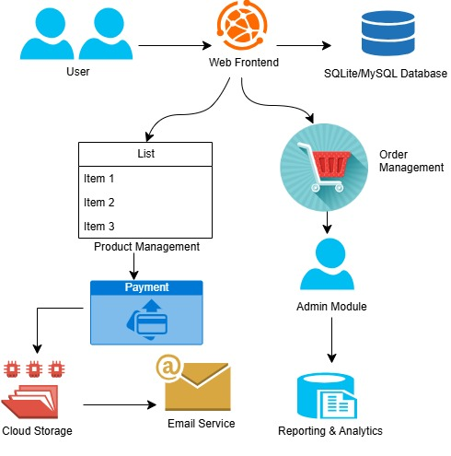

CHAPTER 3: MODULE DESCRIPICTION

3.1 User Management Module
- Stores user information such as username, email, password (hashed), and contact details in the database.
- Manages user authentication by validating credentials against stored data.
- Maintains user roles (e.g., customer, admin) with corresponding access permissions.
- Tracks user registration date and last login timestamp.
- Provides mechanisms for password reset and profile updates stored in the database.

3.2 Product Management Module
- Maintains product records including product ID, name, description, price, category, and stock quantity.
- Supports CRUD (Create, Read, Update, Delete) operations on products via database queries.
- Links product images and additional metadata stored in related tables.
- Tracks product availability and stock levels to prevent overselling.
- Allows searching and filtering products based on categories and attributes stored in the DB.

3.3 Cart and Order Module
- Stores users’ cart items with product IDs, quantities, and prices in temporary or persistent tables.
- Converts cart data into orders by creating order records with status, total amount, and timestamps.
- Links orders with user IDs and shipping details stored in the database.
- Updates product stock quantities upon successful order placement.
- Tracks order history and status changes (e.g., pending, shipped, delivered).

3.4 Payment Module
- Records payment transactions linked to order IDs with payment status and amount in the database.
- Stores payment method details (e.g., credit card type, transaction IDs) securely.
- Updates order status based on payment confirmation.
- Maintains logs for successful and failed payment attempts for auditing.
- Supports refund and cancellation entries by updating transaction records.

3.5 Admin Module
- Provides database access controls to manage users, products, and orders.
- Generates reports on sales, inventory status, and user activity using aggregated data.
- Enables administrative CRUD operations on product and user records.
- Monitors database logs and system errors to ensure smooth platform operation.
- Manages configuration settings stored in database tables for system parameters.
CHAPTER 4: CONCLUSION & FUTURE SCOPE

Conclusion
The Simple E-Commerce Platform designed using a robust Database Management System provides an efficient way to manage users, products, orders, and payments seamlessly. The modular approach ensures scalability and ease of maintenance, enabling smooth user experiences from browsing products to completing transactions. The system's core features ensure data integrity, security, and reliable order processing, making it a practical solution for online shopping needs.
Future Scope
- Integration of Advanced Payment Gateways: Adding support for more secure and diverse payment options such as digital wallets and cryptocurrencies.
- Real-Time Inventory Management: Implementing live stock updates with automated notifications for low inventory to avoid overselling.
- Personalized Recommendations: Utilizing data analytics and machine learning to suggest products based on user behavior and preferences.
- Mobile Application Development: Creating dedicated mobile apps for better accessibility and enhanced user engagement.
- Enhanced Security Features: Incorporating multi-factor authentication and advanced encryption to safeguard user data and transactions.
- Multi-language and Multi-currency Support: Expanding platform accessibility for global users with localization features.

CHAPTER 5: APPENDIX A - SOURCE CODE

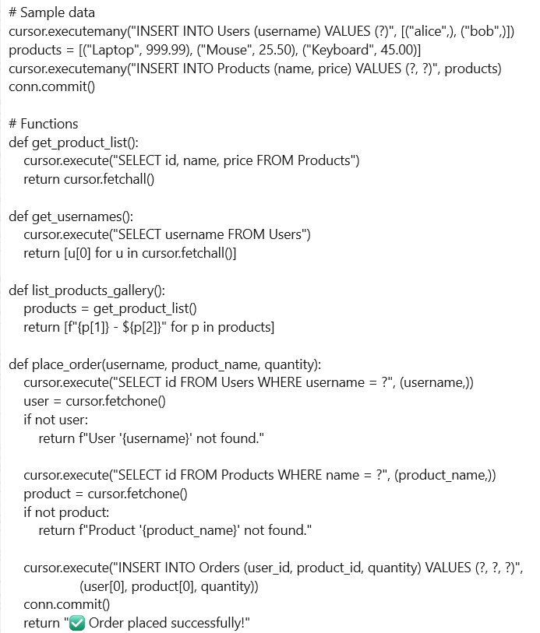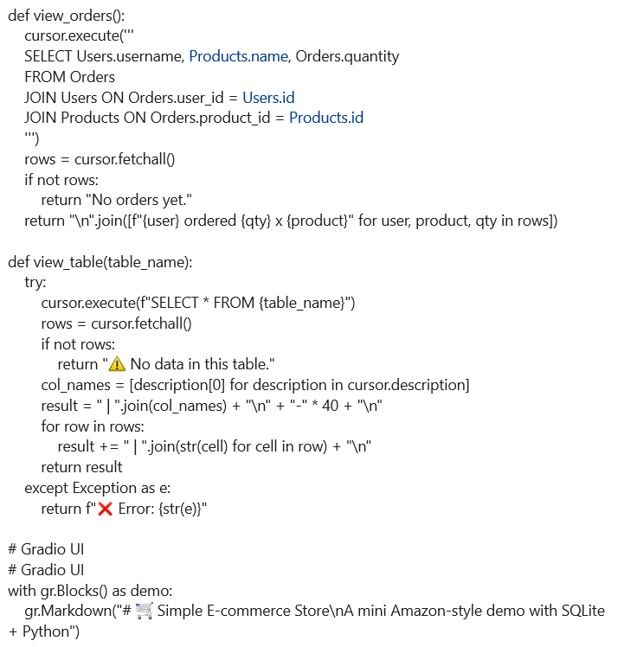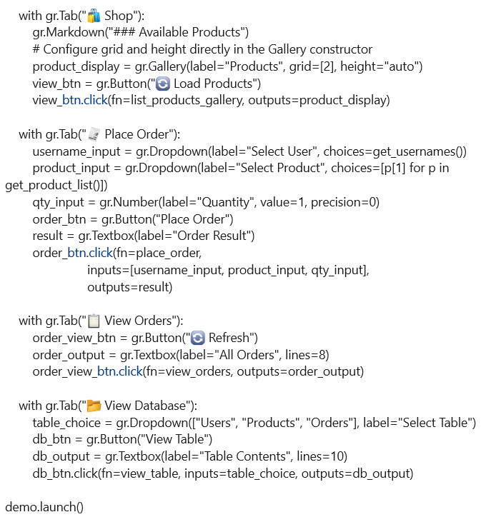

APPENDIX B - SCREENSHOTS
STEP 1:



STEP 2:


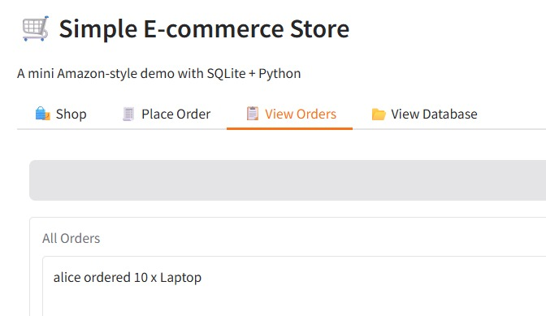
STEP 3:

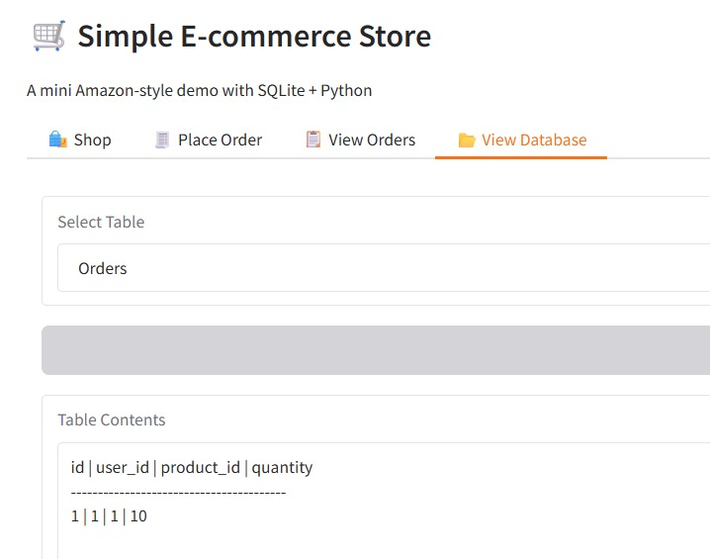
STEP 4:
REFERENCES
APA:
Author/Organization. (Year, Month Day). Title of webpage. Site name. URL
Example:
W3Schools. (n.d.). SQL Tutorial. W3Schools. https://www.w3schools.com/sql/
MLA:
“Title of Webpage.” Website Name, Publisher (if different from website name), Date of publication, URL. Accessed Day Month Year.
Example:
“SQL Tutorial.” W3Schools, https://www.w3schools.com/sql/. Accessed 17 May 2025.
IEEE:
[2] W3Schools, "SQL Tutorial," https://www.w3schools.com/sql/, accessed May 17, 2025.

